--List all the people and their room number, who made the booking for room on 26th Nov 2016

CREATE or ALTER VIEW vBookingList20161121

AS

SELECT concat(first_name, ' ', last_name) AS "guest name", room_no, booking_date

FROM guest

INNER JOIN booking ON guest.id=booking.guest_id

WHERE booking_date = '2016-11-21'

select * from [dbo].[vBookingList20161121]

SQL Server Execution Times:

CPU time = 0 ms, elapsed time = 84 ms.

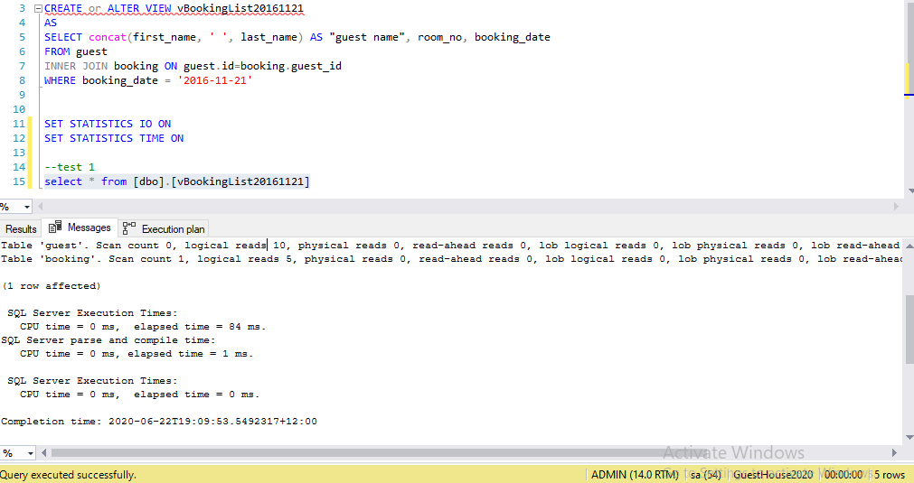

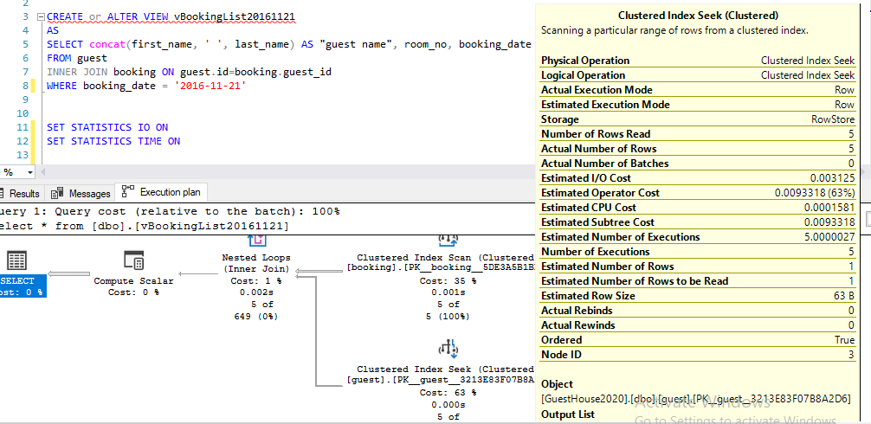

CONCLUSION:

This is a efficient query. As we can see in clustered index seek, number of rows read equal to actual number of rows.